WORK REPORT DAY 2
NAME – NAITIK NEGI DATE – 13-07-2026
WHAT I LEARN TODAY?
Revise the previous topic of embedding
New topic learnt similarity search
Import cosine_similarity
PROBLEM I FACED?
Concept of list in count vectorizer
PRACTICAL IMPLIMENTATION
Revision
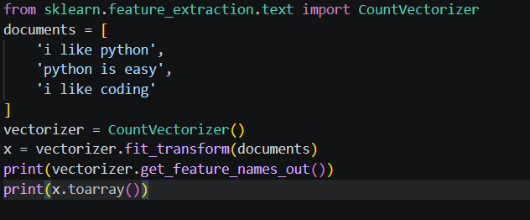
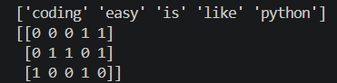
Revision2
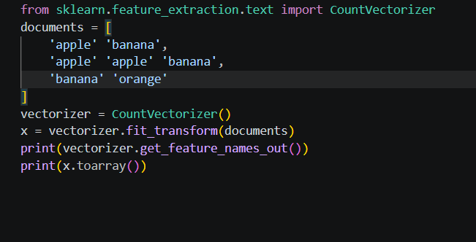

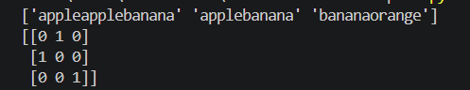

Today
